Application started successfully as shown below.

H2 Console – Tables were created, and data was inserted.

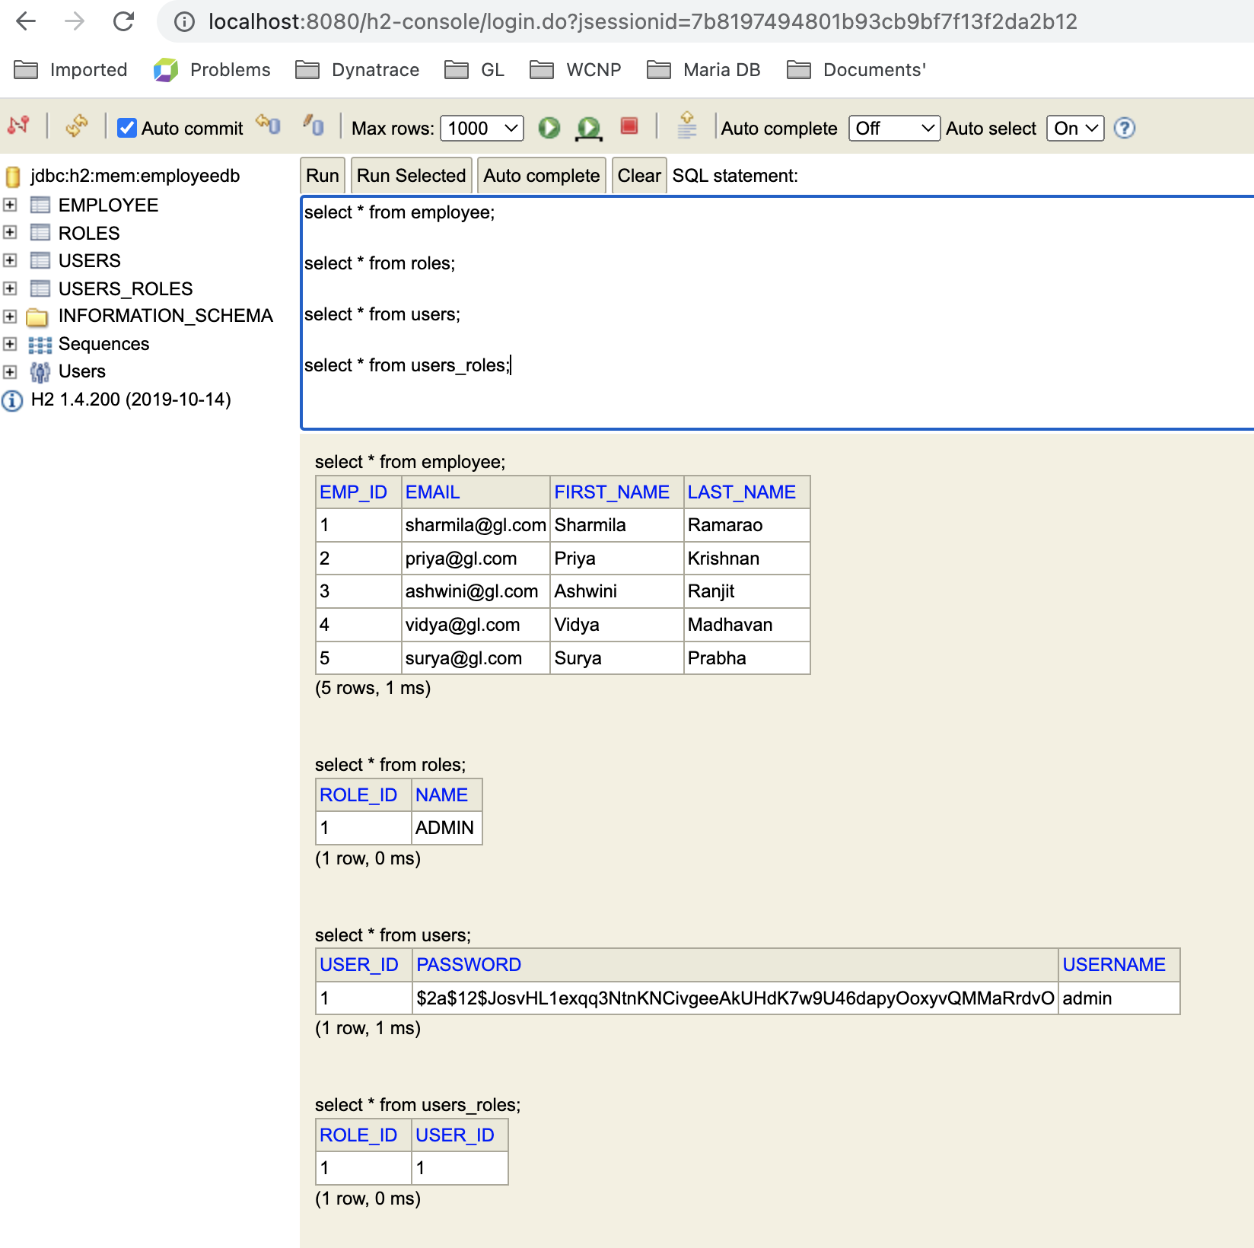

1. Adding roles in the DB dynamically

1. Adding users in the DB.

1. Add Employees in the DB if authenticated user is “ADMIN”

Adding employees using User access

1. List all employees stored in the DB.

5.Fetch a specific employee details using the employee ID 6.

6.Updating the existing record in the DB. Here we are updating the employee id 6’s first name as postman from gl.

The firstname is updated in the H2 database as shown below.

7. Delete Employee- Employee 4 got deleted.

8. Fetch the employee list using their first name.

9. List all employees sorted based on their first name.

Sorting based on descending order

Sorting based on ascending order

----------------------------------------------------xxxxxxxx----------------------------------------------------------------